05 Short term memory
• 5.1 Multistore models of memory
• 5.2 Measuring STM performance
• 5.3 The working memory model
• 5.4 Later revisions of the working memory model
• 5.5 The central executive
• 5.6 Other working memory theories
• 5.7 Neuroimaging studies and working memory

5.1 Multistore models of memory
Early cognitive psychologists believed that there is only one memory store
William janes (1980) states two separate stores
Primary memory – (Later short term memory) For items held briefly in conscious awareness
Secondary memory – (Later long term memory) for items held for longer periods in unconscious storage

Short term memory STM is memory held in conscious awareness and which receives attention
Long term memory LTM is memory held in permanent storage available for retrieval at some point in future

STM is a temporary store of very brief duration and limited capacity while LTM is memories not present in conscious awareness, has large capacities and can hold information for a lifetime

Dual store model of memory

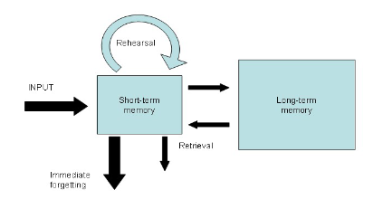

The dual store of memory by Atkinson and Shiffrin is where info is held in STM by continuously rehearsing it and without rehearsal it will be immediately forgotten
LTM is more of a passive store and available for retrieval but not kept in an activated form
In fact there is a third store referring to the sensory store which is a very brief preliminary store for unprocessed sensory info, an after image occurring in the sense organ itselfù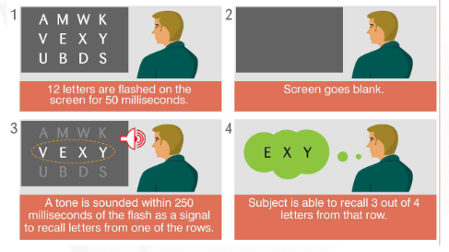
Evidence for STM/LTM distinction is amnesic patients
Patients with organic amnesia (memory impairment cause by physical damage to the brain) have difficulty forming any new long term memories but their short term memory is usually unimpaired
Some patients can remember what happened during the past few seconds but not from earlier time periods
STM can remain intact despite severe impairment to LTM suggests they are separate and independent memory stores

An intact LTM but an impaired STM :
A patient suffered damage to the left parietal region resulting in STM impairment
He can only hold one or two digits in STM at a particular moment in time. Although such situation is rare, other patients show a similar pattern
Digit span is a measure of the capacity of the phonological component of the working memory based on the largest number of digits an individual can recall immediately after presentation

Double dissociation is where STM and LTM are accepted are separate independent memory stores
Recency effect – Items at the end of a list are well remembered
Primary effect – items at the start of the list are remembered but not as much as the end

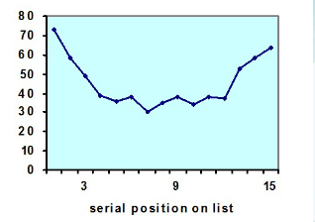

The last few items on the list are remembered because they are in STM at time of recall. This theory receives support from the finding that recency effect disappears when a delay is introduced

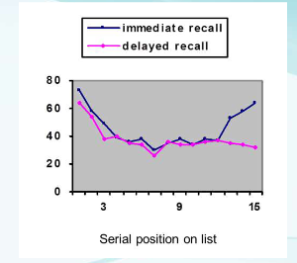

5.2 Measuring STM performance

The brown-peterson task measuring the duration of STM in normal individuals
The participant is presented with the test items well below maximum span (ex: three letters) which are
Required to repeat after a short retention interval
However during this retention interval the participant is required to perform a distraction task to prevent rehearsal of test items
The results obtained that the test items are forgotten very rapidly, mostly within 5 to 10 seconds
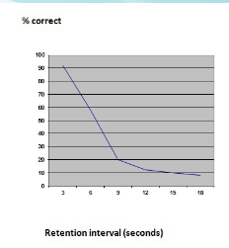
Therefore STM does require rehearsal to keep an items in consciousness.
One popular test is the immediate memory span where participants read a series of items and repeat immediately in correct order. Thew few seconds delay implies the immediate memory span depends on STM
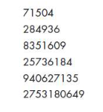

Average normal person can accurately recall 7 +- 2 digits
Immediate memory span is no longer thought to be a pure measure of STM, since there is evidence that LTM
May take contribution

More researchers finds that STM span is significantly reduced when items are unfamiliar, for example a foreign
Language

